# SQLImportStep

**Objective:**

It is used to import the data into selected DB.

**Attributes:**

|  |  |
| --- | --- |
| **Attributes** | **Description** |
| file_url | To enter the file url to get data |
| header_mappings | To get header mappings |
| table | Used to store the data into a particular table |
| count | To enter the count of data |
| output_variable | Used to store the response of the request |
| plugin_name | To connect with mysql server based on the plugin credentials |

**Sample config.json:**

{

"workflows":[

{

"name":"sql_import",

"id":1828,

"trigger":"rest",

"expression":"/sqlimport",

"method":"GET",

"steps":[

{

"type":"start",

"id":1,

"next":{

"start":"2"

}

},

{

"id": "2",

"type": "sql-export",

"value":"select * from test",

"value_type": "hb",

"plugin_name": "user_mysql",

"next":{

"success": "3",

"failure": "hangup"

}

},

{

"id": "3",

"type": "sql-import",

"file_url":"http://localhost:8080/sqlexport",

"output_variable": "hb",

“header_mappings”: “id,nameselect * from test”,

“table”: “test“,

“count”: “6“,

"plugin_name": "user_mysql",

"next":{

"success": "4",

"failure": "hangup"

}

},

{

"http_response_code":"200",

"response_content_type":"application/json",

"value_type":"hb",

"type":"send",

"id":"4",

"next":{

"success":"hangup",

"failure":"hangup"

}

}

]

}

],

"filters":[],

"server":{},

"plugins":[

{

"id": 243,

"name": "user_mysql",

"type": "mysql-plugin",

"version": "1.0",

"category": "Database",

"server": "localhost",

"username": "root",

"password": "root",

"schema": "testDB"

}

]

}

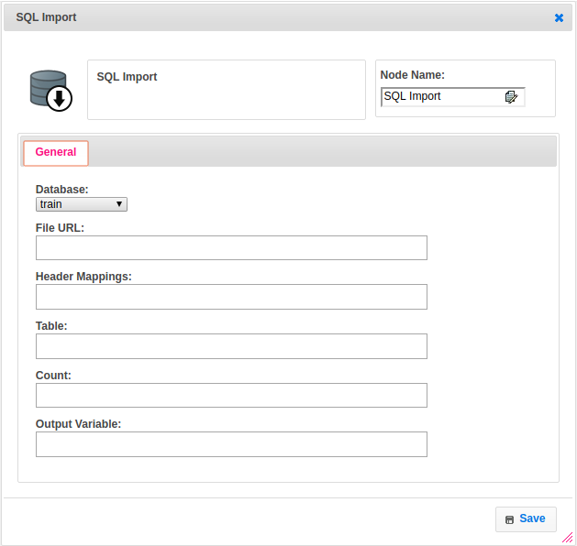

**Executor Description:**

In executor class first it will download the file by using file_url if the file name is not present in local then it get the temporary file name and get the header mappings to import the data. Then it loads the data into table by using SQLDBUtil class and put the result into output variable, returns step status as success.